**Silos.**

This is a structure that can keep your resources safe. Only one can be built, in your main base, and will keep resources safe in every one of your cities.

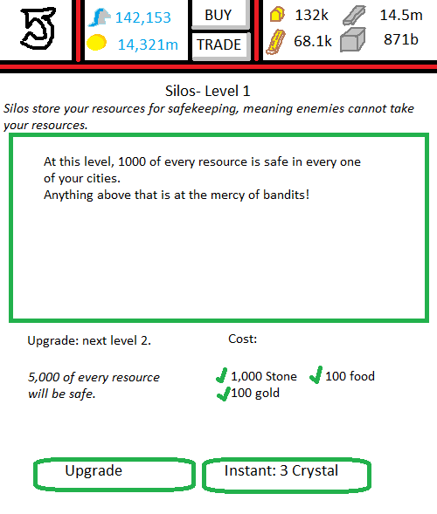

**User Interface: Main Base.**Selecting the silo opens a mini-menu. 2 options are given:  
 1. Go to silo.  
 2. Upgrade.

**User Interface: Silo.**There are no special functions that exist with this building.  
‘Upgrade’ will be ghosted if you do not have the correct resources. If you do, and you click it, your building will go into the building queue.   
‘Instant: 3 crystal’ will instantly upgrade your silo to level 2, without a build queue, and will deduct 3 crystal from your balance.

**Graphics in use:**GIMB_026. (1) Silos. Graphic of silo from level 1 to 4.  
GIMB_027. (2) Silos. Graphic of silo from level 5 to 9.  
GIMB_028. (3) Silos. Graphic of silo from levels 10+.

**Variables in use:**VS_SL1. Variable of your silo, storing its level.